IDEATION PHASE

BRAINSTORM & IDEA PRIORITIZATION TEMPLATE

|  |  |
| --- | --- |
| Date | JUNE 2025 |
| Team ID | LTVIP2025TMID50867 |
| Project Name | ToyCraft tales: tableau's vision into toy manufacturer data |
| Maximum Marks | 4 Marks |

Step-1: Team Gathering, collaboration and select the problem statement

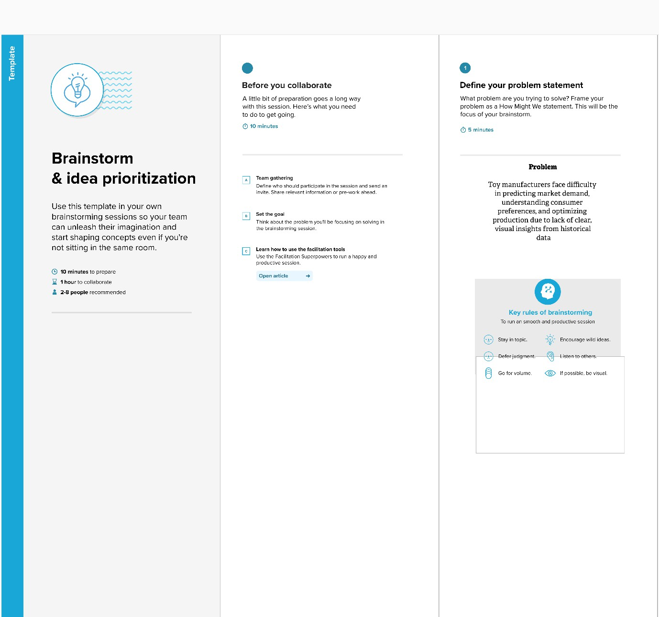

Step-2: Brainstorm, Idea Listing and Grouping

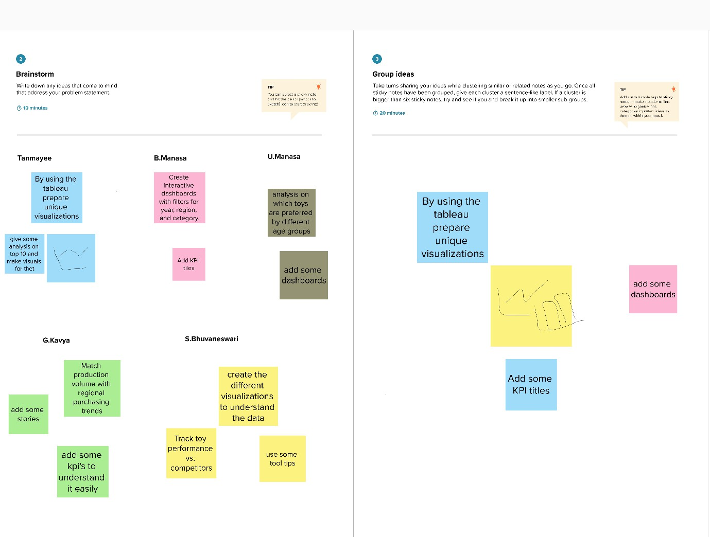

Step-3: Idea prioritization

